**Chatting Application using Swing and Socket Programming**

Firstly, Socket programming is a network programming used for creating applications that communicate each other over a network.

In java the socket programming is client server model where there will be a client and a server, Here the localhost used where the server and the client are connecting with each other. There will be one class of client which was created by using the socket class which have the interfaces to that having methods like connect and closable and auto closable. And the server Socket is the class that used to create server class which also has the inbuilt interfaces implementation for closable and Auto closable along with that the server socket also implements the runnable interface which is used to run that is having the run single method that can also implement by the lambda expression. Runnnable is an interface which has only one method run() that can be implement by starting the Thread, Thread is a class which has the implemented interfaces having the methods like start(), wait(), Interrupt(). The awt class is also used for the helper to change the look of the gui application.

JSwing is used to create a GUI application for login the user as client, Signing up new user also for the chatting interfaces for server and the client sides.

JDBC is the Java Database Connectivity which is used to connect the database and the gui application by applying the event handling on the gui application. LocalDate is the class that used to print time that the message is send by the server side and the client side, DateTimeFormatter is used to format the date only to display the time that message sent.

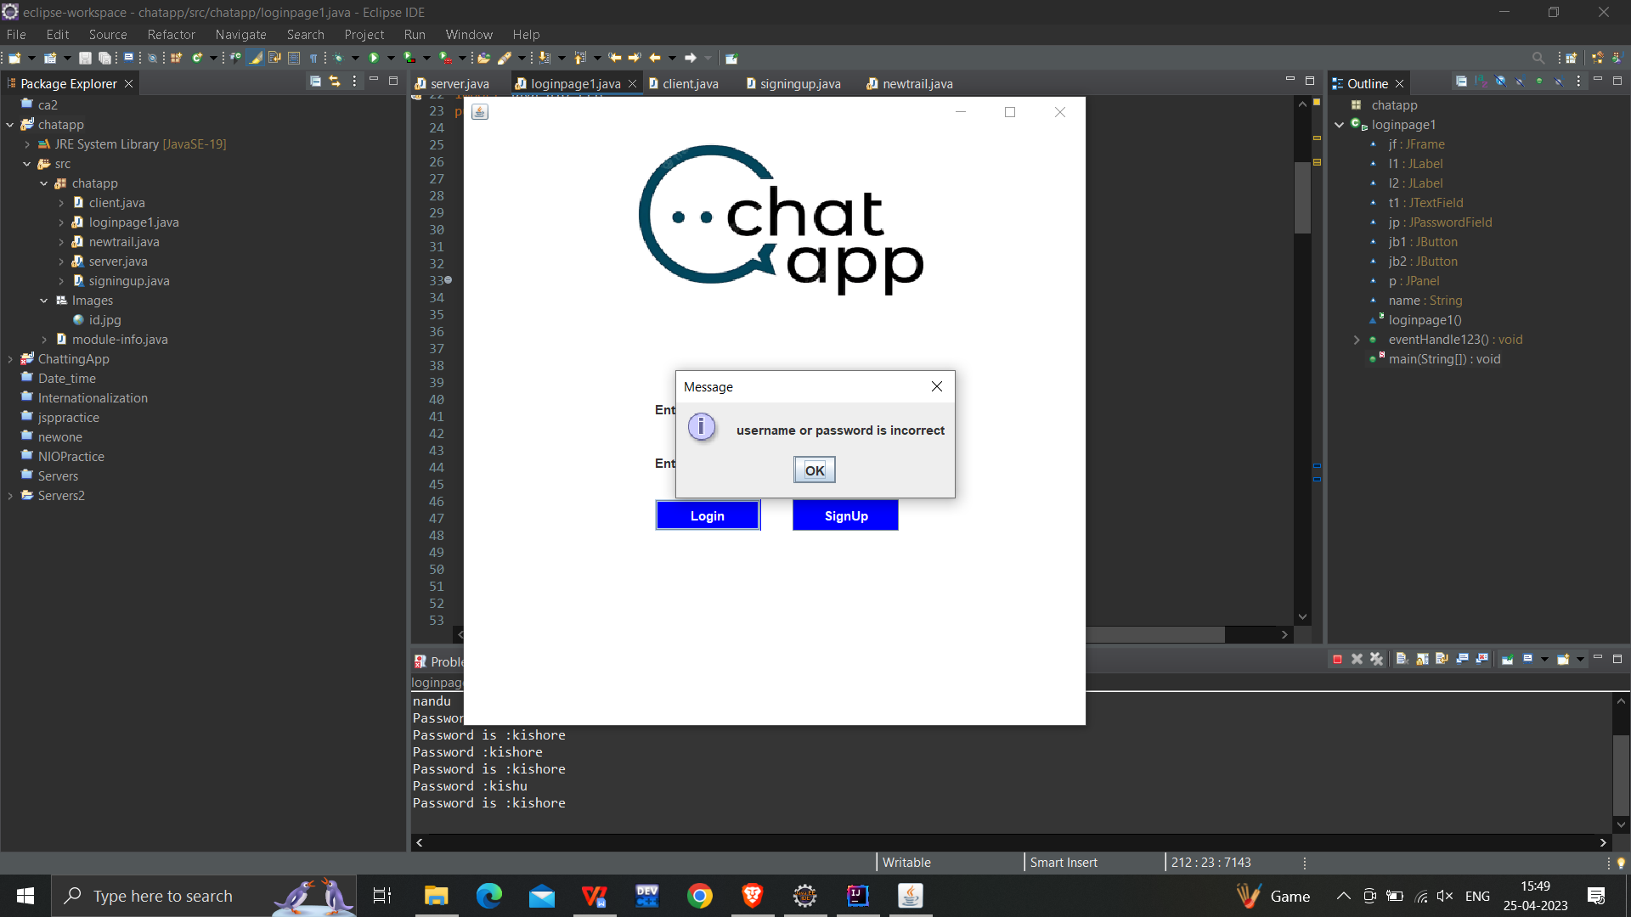The login process is success when the user entered the correct credentials. Else it shows the credentials not correct.

In case the login credentials are not there for the client then the credentials can be create by the signup options.

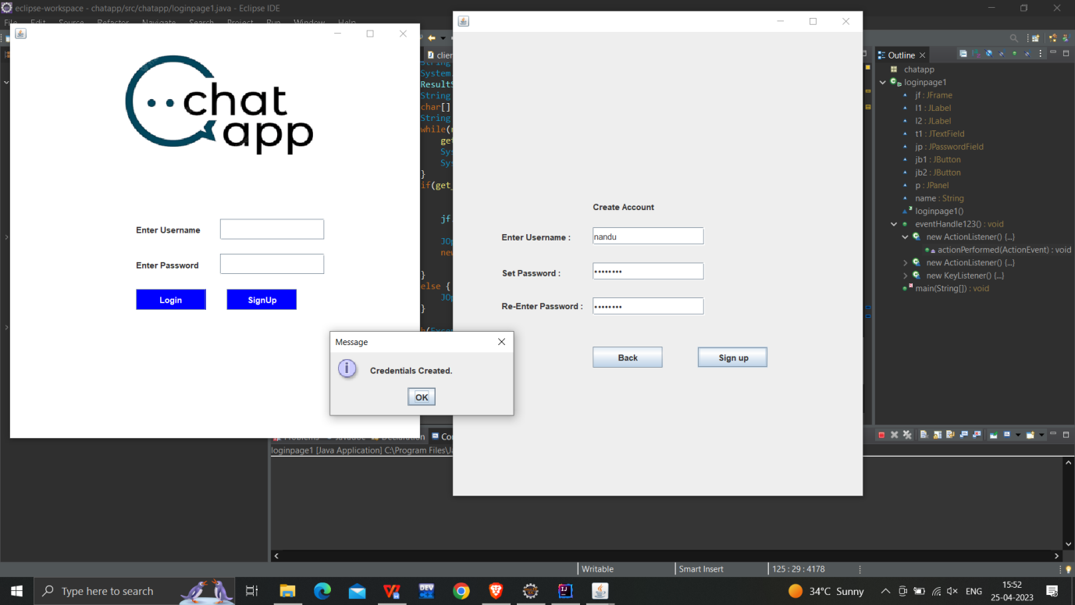

The above picture shows the credentials saved.

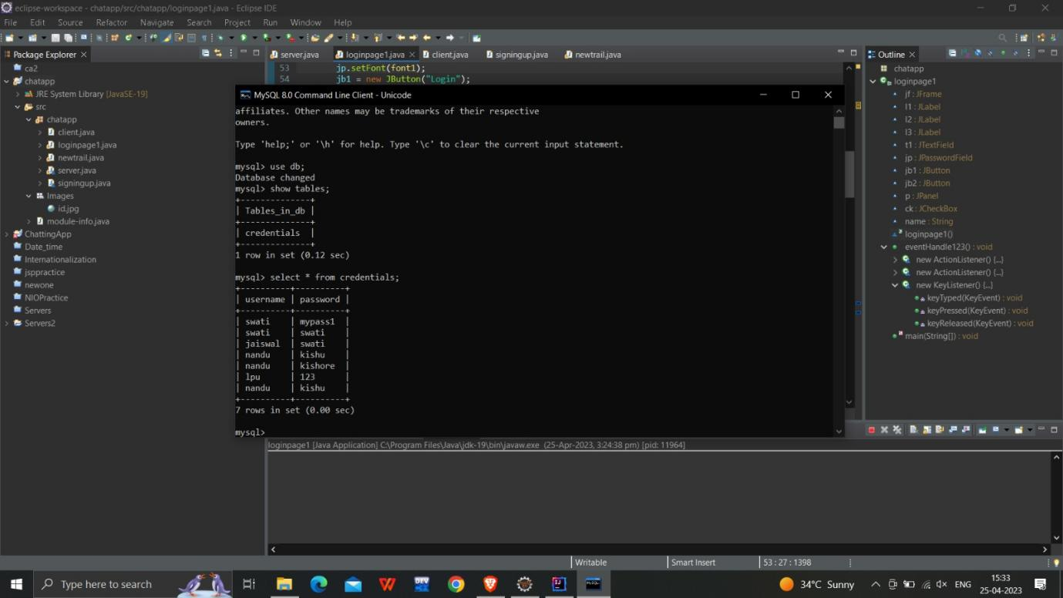The below pictures shows the saved credentials in the table name credentials of username “nandu” this is by the jdbc connectivity where the database is connected to the signup page.

After creation of credentials then the user can login with the credentials that have been created by the person, the below picture shows the login success portion.

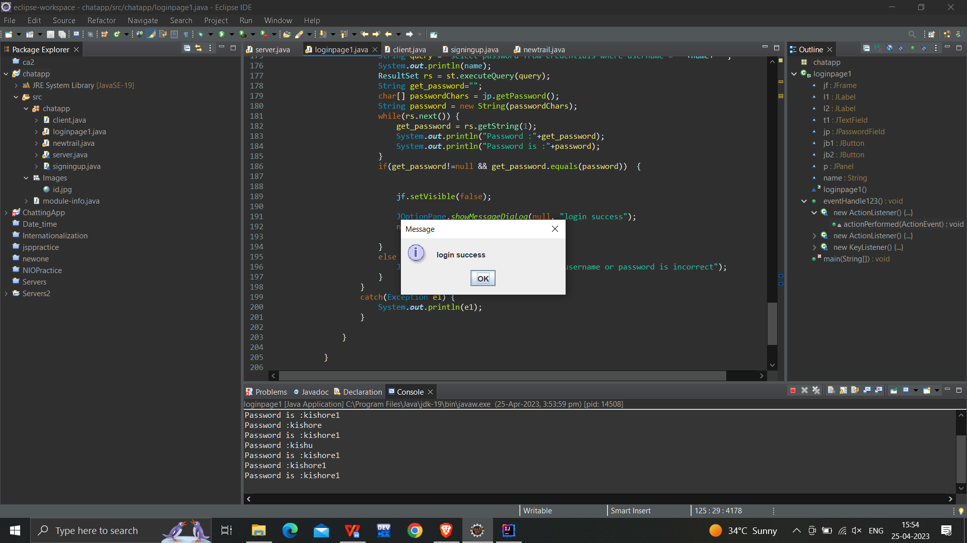

After Login the client the client will send the request to the server with the help of IPAddress and ask for the connection to port by setting the port number only if the login credentials are correct. The port numbers are same then the server accept the request and then the server and client both can be connect and chat with each other. The below picture shows the chatting of both the server and client.

